Centerville Road

Rally

Central

*

Hiatt Road

Ranft Road

First Aid

Service

# 9

Campground

Placerville

Granite Creek Road

Yet Kee Road

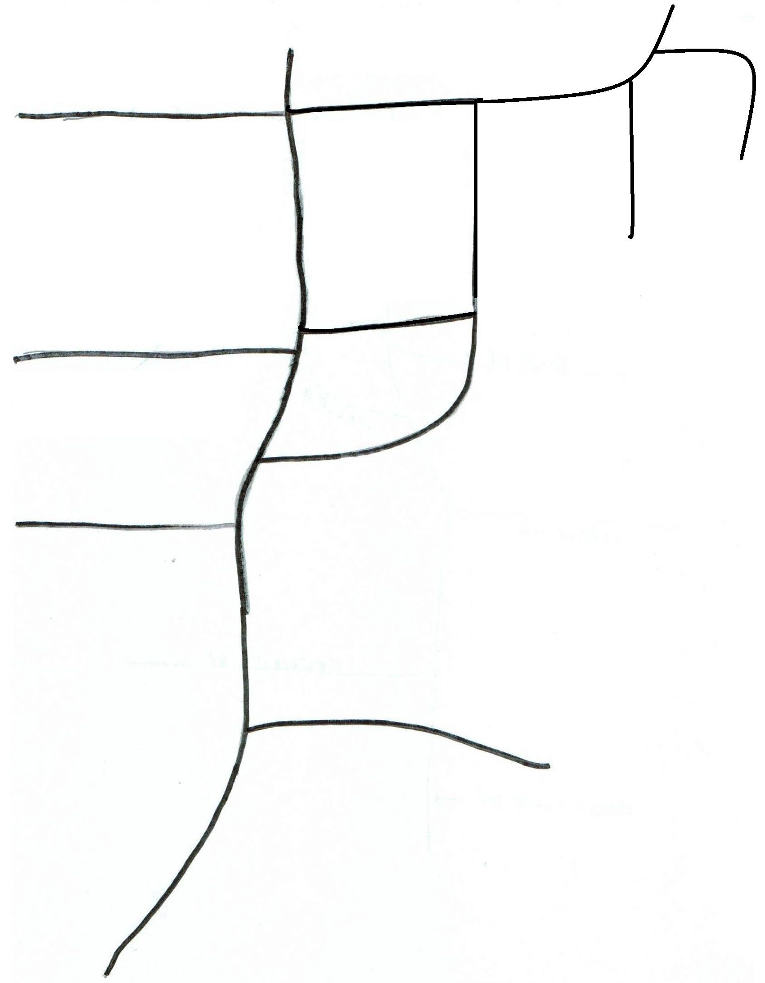

Stanifir Road

Service

# 8

Mail

Boxes

Mesplie Road

Harris Creek Road

Service

# 7

Service # 6

Service

#5

Communication

Control

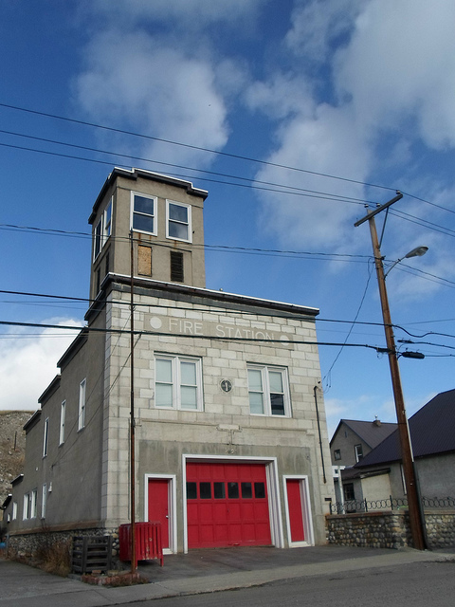

Service

# 3

Fire Station

Service

# 2

Masonic Lodge

Service

# 4

*Rally Central

Times/Scoring

Service Area Information

Volunteer Sign-In

Meals

Tee-Shirt sales

Bulletin Boards

Service #1 -

(By Permission Only)

Museum

Old

Centerville Road --->

Map is not to scale