2015 Idaho Rally

Preliminary (5-7-15)

Supplementary Regulations

June 13-14, 2015

The General Regulations are available on the NASA Rally Sport web site <http://www.nasarallysport.com/main/rules>

This year we will be a NASA sanctioned event. All competitors must have a NASA competition license (UTVs- may purchase a $45 membership for this event) and a NASA Medical Form signed by their doctor and submitted 72 hours prior to registration.

California Rally Series Rules are available at the CRS website

<http://www.californiarallyseries.com/Current/Rulebook/index.aspx>

Welcome Message from the Chairman

Hello and welcome to the Idaho Rally 2015. Thanks for coming to Idaho, we are very happy to have you here.

As each year of the Idaho Rally has done before, this year promises to be bigger and better than ever! This year we will run all stages in Boise County. This will allow us to make the transits much shorter after we get to the stages.

I have no doubt that you will like the stages. We really hope you will also enjoy the rest of the weekend’s program and will want to come back. I wish you the best and hope you have a great and safe weekend at the Idaho Rally.

Rob Blout

IR15 Chairman and Clerk of the Course

Rally Office Mailing Address Dick Rockrohr Director IRG

Idaho Rally Phone 208.867.6943

9150 S Talon Ln Email buellracer1@yahoo.com

Boise, ID 83709 Web [www.idahorally.org](http://www.idahorally.org)

# Table of contents

1.0 INTRODUCTION

2.0 ORGANIZATION AND DESCRIPTION

3.0 RALLY SCHEDULE

4.0 LOCATION OF RALLY OFFICE AND HEADQUARTERS

5.0 ENTRIES

6.0 INSURANCE

7.0 ADVERTISING AND IDENTIFICATION

8.0 TIRES

9.0 FUEL

10.0 RECONNAISSANCE

11.0 TESTING

12.0 ORGANIZER SUPPLIED NOTES

13.0 ADMINISTRATIVE CHECKS (REGISTRATION)

14.0 FEATURES OF THE RALLY

15.0 PRIZES

16.0 FINAL CHECKS AND PROTEST

17.0 SUPERRALLY RESTART PROCEEDURE

18.0 NOVICE COMPETITOR ORIENTATION

19.0 UTV Rules

APPENDICES

APPENDIX 1 – RECONNAISSANCE SCHEDULE

APPENDIX 2 - COMPETITION NUMBERS AND ADVERTISING

APPENDIX 4 GENERAL CONDITIONS

APPENDIX 5 MAPS AND GENERAL INFORMATION

APPENDIX 6 RADIO FREQUENCIES FOR RALLY

APPENDIX 7 TIME CARD SAMPLE

# INTRODUCTION

1.1 RULES AND REGULATIONS

This rally will be run in compliance with the NASA Rally Sport General regulations for Rallies with Appendices, using an FIA-type timing system (refer to sups section 14.2 and Appendix 5). Modifications, amendments, or changes to these Supplemental Regulations will be made only by numbered versions and dated bulletins issued by the Clerk of the Course or the Stewards.

1.2 ROAD SURFACE

The stages are 99% decomposed granite.

1.3 DISTANCES

SS 115.49 miles

Total 303.18 miles

# 2.0 ORGANIZATION AND DESCRIPTION

2.1 TITLES FOR WHICH THE RALLY COUNTS

California Rally Series

Pacific Rally Cup

Cascadia International Rally Cup

2.2 NAME OF ORGANIZING CLUB:

Idaho Rally Group, Inc.

2.3 NAME OF PROMOTER:

Idaho Rally Group, Inc.

2.3.1 ADDRESS AND CONTACT DETAILS

Idaho Rally Phone +1.208.867.6943

9150 S Talon Ln

Boise, ID 83704

Email: buellracer1@yahoo.com

2.4 ORGANIZING COMMITTEE

Chairman/Clerk of the Course: Rob Blout

2.5 STEWARDS OF THE MEETING

Chairman: Dick Rockrohr

NRS Event Steward: Kristopher Marciniak

Steward: Roger Tipton

2.6 SENIOR OFFICIALS

Event Chairman/Clerk of the Course: Rob Blout

Assistant Chairman: Carl Somerton

Safety Officer: Rob Blout

Chief Scrutineer: Carl Somerton

Competition Relations Officer: Amy Alderman

Chief of Communications: Tim Rynearson

Chief of Scoring: Mike Gibeault

Service Area Manager: George Thomas

Competitor Relations Officer: Sarah Blout-Hemlick

2.6.1 Stage Captains:

Harris Creek Stage: Darnal Alexander

Grimes Pass Stage: Brent Rule

Alder Creek Stage: Brandon, Rachel Paige

# 3.0 RALLY SCHEDULE /STAGE SCHEDULE

3.1 PRE-EVENT DATES

Early Entry Open Feb 2, 2015

Regular Entry Open, May 7, 2015

Late Entry Open June 5, 2015

Paperwork Completion Deadline Friday, June 12, 2015

3.2 WEEK OF EVENT SCHEDULE

3.2.1 Thursday, June 11th, 2015

|  |  |  |
| --- | --- | --- |
| 09:00-11:00 | Press Stage | Centerville Rd Idaho City |
| 18:00 – 22:00 | Opening of Rally Office | Best Western + Northwest Lodge |
| 18:00 – 22:00 | Administrative Check-in Competitors | Best Western + Northwest Lodge |
| 18:00 – 22:00 | Registration for Reconnaissance | Best Western + Northwest Lodge |
| 18:00 – 22:00 | Worker Registration | Best Western + Northwest Lodge |
| 18:00 – 21:00 | Tech inspection for Recce participants | Main Service Park Best Western + Northwest Lodge |

3.2.2 Friday, June 12th, 2015

|  |  |  |
| --- | --- | --- |
| 06:00 –16:00 | Reconnaissance SS1-11 | Boise County |
| 07:00-09:00 | Registration open/late Recce registration | Best Western + Northwest Lodge |
| 15:00-19:00 | Registration Open | Larry H Miller Subaru |
| 17:30-19:00 | Workers Registration | Placerville service Park |
| 16:00-20:00 | Scrutineering | Larry H Miller Subaru |
| **17:00-18:30** | **PARK EXPOSE MANDATORY\***  **\*\*\*NO TRAILER PARKING AVAILABLE ON SITE\*\*\*** | **Larry H Miller Subaru (Trailer parking on side road see instructions)** |
| **\*ALL COMPETITORS** | **VEHICLES MUST BE IN PARK EXPOSE OR $100 FINE WILL BE IMPOSED** | **SPECIAL CIRCUMSTANCES WILL BE REVIEWED** |
| 19:00-20:00 | Novice Competitor Orientation | Best Western + Northwest Lodge |
| 18:00 | CRS Stock Meeting | Larry H Miller Subaru |
| 20:00 | Stewards Meeting | Best Western + Northwest Lodge |
| 22:00 | Publication of Start Order | Best Western + Northwest Lodge |

3.2.3 Saturday June 13th, 2015

|  |  |  |
| --- | --- | --- |
| 07:00 – 08:00 | Opening of Rally Office and Official Notice Board | Best Western + Northwest Lodge |
| 09:30 | Drivers Meeting Time Cards | West end of Harris Creek at drop zone |
| 10:00 | First Car on Stage | TC 1 |
|  |  |  |
| 19:00 | Stewards Meeting | Placerville service Park |
| 21:00 | Provisional Results posted for day 1 | Best Western + Northwest Lodge |
| 22:00 | Publication of start order for day 2 | Official Notice Board Best Western + Northwest Lodge |

3.2.4 Sunday June 14th, 2015

|  |  |  |
| --- | --- | --- |
| 06:45 | Drivers Meeting | West end of Harris Creek at drop zone |
| 06:30-07:00 | Park Expose | West end of Harris Creek at drop zone |
| 07:00 | Leave Service Park | West end of Harris Creek at drop zone |
| 7:15 | First Car on Stage | TC 7 |
|  |  |  |
| 15:00 | Awards ceremony | Placerville service Park |
| 15:30 | Stewards Meeting | Placerville service Park |
| 15:45 | Sunday Scores published | Placerville service Park |
| 16:15 | Results go final and Award Ceremony Starts | Placerville service Park |
| 18:00 | Awards ceremony closes | Placerville service Park |

# 

3.3 STAGE SCHEDULE

3.3.1 DEFINITIONS

TC : Time Control

TIME ALLOWED : Total time from control to control

MPL:  Maximum Permitted Lateness is, 30 minutes total. For road opening purposes on stage: any competitor who's time exceeds the Bogey time +15 minutes, will have their time card pulled by sweep and be prohibited from finishing that stage. This will not prevent them from using Superrally rules and re-entering the Rally at a later point (either after a service or at the start of the next day). See NRS GRRs Article 2.22.6 for Superrally rules.

3.3.2 LEGS 1 AND 2

|  |  |  |  |  |  |  |  |  |  |
| --- | --- | --- | --- | --- | --- | --- | --- | --- | --- |
|  | **LEG I SATURDAY IDAHO RALLY 2015** | | | | | |  |  |  |
| **CONTROL** | **FCI** | **FCO** | **NAME** | | **STAGE MILES** | **TRANSIT MILES** | **TIME ALLOWED** | **AVG SPEED** | **BOGEY TIMES** |
| HOST HOTEL TO DRIVERS MEETING |  | 8:00 |  | |  | 42 |  |  |  |
|  | 9:30 |  | DRIVERS MEETING WEST END OF HARRIS CREEK STAGE | |  |  |  |  |  |
| TC 1 | 10:00 | 10:03 | HARRIS CREEK EAST 1 & service (about 15 min) | | 12.7 | 2.82 | 50 |  | 26 |
| TC 2 | 10:53 | 10:56 | SERVICE OUT / ALDER CREEK NORTH 1 | | 6.53 | 11.89 | 60 |  | 14 |
| TC 3 | 11:56 | 11:59 | GRIMES PASS SOUTH 1 SERVICE RESEED (about 60 min) | | 12.92 | 0.25 | 90 |  | 26 |
| TC 4 | 13:29 | 13:32 | SERVICE OUT / ALDER CREEK NORTH 2 | | 6.53 | 11.89 | 60 |  | 14 |
| TC 5 | 14:32 | 14:35 | GRIMES PASS SOUTH 2 (about 45min service) | | 12.92 | 0.25 | 85 |  | 26 |
| TC 5A |  | 16:00 | SERVICE OUT | |  | 2.92 | 12 |  |  |
| TC 6 | 16:12 | 16:15 | HARRIS CREEK WEST 1 | | 12.59 | .25 | 30 |  | 26 |
|  |  |  | HARRIS CREEK WEST STOP CONTROL IS THE FINAL CONTROL OF THE RALLY TODAY NO time penalty UNLESS ARRIVAL IS GREATER THAN BOGEY TIME+30 MINUTES | |  |  |  |  |  |
| FINISH TO HOST HOTEL |  |  | Rally is over for today | |  | 42 |  |  |  |
|  |  |  |  | |  |  | ATV,UTV, MOTORCYCLE TRANSIT MILES | TOTAL MILES CARS | TOTAL MILES ATV, UTV, MOTORCYCLE |
| **SAT TOTALS** |  |  |  | | **64.19** | **114.27** | **30.27** | **178.46** | **94.46** |
|  |  | | | | | |  |  |  |
|  | **LEG 2 SUNDAY IDAHO RALLY 2015** | | | | | |  |  |  |
| **CONTROL** | **FCI** | **FCO** | **NAME** | **STAGE MILES** | | **TRANSIT MILES** | **TIME ALLOWED** | **AVG SPEED** | **BOGEY TIMES** |
| HOST HOTEL TO PARK EXPOSE |  |  |  |  | | 42 |  |  |  |
|  | 6:45 | 7:00 | West end of Harris Creek at drop zone |  | | 1 | 15 |  |  |
| TC7 | 7:15 | 7:18 | HARRIS CREEK EAST 2 SERVICE & BREAKFAST STOP | 12.7 | | 2.82 | 80 |  | 26 |
| TC 8 | 8:38 | 8:41 | GRIMES PASS NORTH 1 | 12.7 | | 11.89 | 75 |  | 26 |
| TC 9 | 9:56 | 9:59 | ALDER CREEK SOUTH 1 (about 60 min service) | 6.6 | | .25 | 90 |  | 14 |
| TC 10 | 11:29 | 11:31 | GRIMES PASS NORTH 2 | 12.7 | | 11.89 | 75 |  | 26 |
| TC 11 | 12:46 | 12:49 | ALDER CREEK SOUTH 2  STOP CONTROL IS THE FINAL CONTROL OF THE RALLY NO time penalty UNLESS ARRIVAL IS GREATER THAN BOGEY TIME+30 MINUTES | 6.6 | | 3.17 | 30 |  | 14 |
|  |  |  | FROM FINISH TO AWARDS BANQUET |  | | .4 |  |  |  |
|  |  |  |  |  | |  | ATV,UTV, MOTORCYCLE TRANSIT MILES | TOTAL MILES CARS | TOTAL MILES ATV, UTV, MOTORCYCLE |
| **SUN TOTALS** |  |  |  | **51.3** | | **73.42** | **31.42** | **124.72** | **82.30** |
| **GRAND TOTAL** |  |  |  | **115.49** | | **187.69** | **61.69** | **303.18** | **177.18** |
|  |  |  |  |  | |  |  |  |  |

# 4.0 LOCATION OF RALLY OFFICE AND HEADQUARTERS

4.1 RALLY OFFICE

Thursday, June 11, 2015

Friday, June 12, 2015

Saturday, June 13, 2015

Sunday June 14, 2015

4.2 RALLY HEADQUARTERS

Best Western + Northwest Lodge

6989 Federal Way

Boise, ID 83716

208-287-2300, 866-385-6343

RESERVATIONS MUST BE IN BY May 30, 2015 (To get the special rate $85.99+tax)

4.3 LOCATION OF RALLY CONTROL

Best Western + Northwest Lodge

6989 Federal Way

Boise, ID 83716

208-287-2300

4.4 LOCATION OF STAGES

4.5.1 Saturday and Sunday

Stages take place in Boise County between Boise, Idaho City, Garden Valley and Horseshoe Bend.

# 5.0 ENTRIES

5.1 ENTRY PROCEDURE AND ELIGBLE CLASSES

Competitors wishing to take part in the 2015 edition of the Idaho Rally must submit their completed entry form and payment of all funds by June 12, 2015. Details of the co-driver must be submitted by June 12, 2015.

For an entry to be considered complete, the following must be submitted:

The entire entry fee

Complete driver information ,including NASA medical form

Complete co-driver information , including NASA medical form

[www.nasarallysport.com/main/Do_I_need_a_medical_form](http://www.nasarallysport.com/main/Do_I_need_a_medical_form)

State-Issued Drivers Licenses of the driver and co-driver

NASA Membership ($45 for 365-day membership from NASA - required for ALL entrants)

NRS Competition License ($50) or CARS License for all Car Entry Competitors (Drivers and Co-Drivers)

At the rally, all competitors must sign:

The NRS General Liability Waiver

The NRS Vehicle Registration and Insurance Waiver

The NRS Multi-Waiver

5.2 ELIGIBLE CAR AND RALLY MOTO CLASSES

|  |  |  |
| --- | --- | --- |
| **CRS** | **PRC** | **CIRC** |
| Open* | AWD* | O4wd* |
| Open Lite* |  | L4wd* |
| CRS-2* | 2WD* | O2wd* |
| Performance Stock* |  | L2wd* |
| **Rally** **moto** |  | **UTV** |
|  |  | Production 750 (SBS Class 3)  (under 705cc)* |
|  |  | Production 850 (SBS Class 2)  (Under 850cc)* |
|  |  | Production 990 (SBS Class1)  (under 990 cc)* |
|  |  | Production 1000 (over 991 cc) (2014 Razor 1000 class |
|  |  | Unlimited  (ISSA Unlimited 4 and 2)* |
|  |  | Experimental (Non production based, any combination of frame and engine)* |

* Designated Classes for championship points will be awarded per day but trophies awarded per finish of both days. **Super Rally rules apply**

5.3 ENTRY FEES AND PACKAGES FOR ALL COMPETITORS

5.3.1 Early Entry Fees before May 11, 2015

National and Regional Cars $650**

UTVs $400*  
*Stage notes are included for all Entries

Recce is FREE

5.3.2 Regular Entry Fees between May 12 and June 4, 2015

National and Regional Cars $700**

UTV’s $400  
 **Stage notes are included for all Entries

Recce is FREE

5.3.3 Late Entry Fees after June 5, 2015

National and Regional Cars $750**

UTV’s $450  
**Stage notes are included for all Entries (subject to availability)

Recce is FREE

5.3.4 The Entry Fee Includes

1 Includes Organizer-Supplied Stage Notes and Reece

4 BBQ Lunch tickets Saturday

4 Awards Banquet tickets (additional ticket available for purchase)

4 Tickets for the Sunday Morning Pancake Breakfast

1 Route Books including sups and notes

1 Reconnaissance Instructions

2 Competitor Wrist Band Passes

4 Service Personnel Wrist Band Passes

1 Route Book for Service Personnel

1 set of Event Logo Vinyl

5.4 PAYMENT DETAILS

Entry must include full payment. All payments must be US funds drawn on a US bank.

Sign up on Rally data.com - then there are two ways to pay:

1) Use Pay Pal OR  
*2) Mail a check Payable to:*

Idaho Rally   
9150 S Talon Ln

Boise, Idaho 83709

5.5 REFUNDS

5.5.1 If the participant’s entry is rejected, entry fees will be paid in full.

5.5.2 If the rally is not held, entry fees will be paid in full.

5.5.3 Entries withdrawn by Monday, June 1, 2015, will have $50 withheld for

Processing.

5.5.4 Entries withdrawn on or after Tuesday, June 2, 2015, will have $100 withheld for processing.

5.5.5 If the vehicle does not pass tech, $100 will be withheld for processing.

5.6 Idaho Rally Group’s towing rebate for the 2015 Larry H. Miller

Idaho Rally International

**\*\*\*\*\*\*NOTE: You must sign up by June 4, 2015 to receive the FULL tow fund. After June 4thTow is at the reduced rate table below the FULL RATE TABLE. Fund for car entries only.**

**FULL TOW FUND REBATE RATE TABLE**

Rally, one way Rebate amt.

300-400 $50.00

401-500 $75.00

501-550 $100.00

551-600 $125.00

601-650 $150.00

651-700 $175.00

701-750 $200.00

751-800 $225.00

801-1100 $250.00

1101 up $400.00

The rebate amount will be determined by your home address and refunded at registration.

**\*\*\*\*\*\*NOTE: You must sign up by June 4, 2015 to receive FULL tow fund. Discounted Tow fund schedule below. Tow fund for car entries only.**

**LATE TOW FUND REBATE TABLE**

Rally, one way Rebate amt.

300-400 $33.00

401-500 $49.00

501-550 $65.00

551-600 $82.00

601-650 $98.00

651-700 $114.00

701-750 $130.00

751-800 $147.00

801-1100 $163.00

1101 up $260.00

The rebate amount will be determined by your home address and refunded at registration.

Thanks to the hard work of the club members and our sponsors we can offer this to all car entries that sign up before June 4, 2015 when the regular entry closes.

# 6.0 INSURANCE

6.1 LIABILITY COVERAGE

The entry fee includes the insurance premium to insure the competitor and other parties as necessary against all third party bodily injury and property damage for the amount of $5,000,000. There is $1,000,000.00 EXCESS competitor medical insurance provided.

6.2The Entry Fee includes the insurance premium to insure the competitor and other parties as necessary against all third party bodily injury and property damage for the amount of $5,000,000 per occurrence.

6.3Description of Accident Medical Coverage

All competitors, service crews and all event participants (staff, marshals, volunteers, etc.) have secondary medical coverage of $1,000,000. There is a $1,000 deductible for those without their own primary medical coverage.

6.4Period of Insurance Coverage

In general all insurance coverage will come into effect at the opening of the Rally Office. For each participant it begins when they sign the NRS general liability waiver. Insurance coverage will end at the close of the Rally Office or at the moment of competitor retirement, exclusion or disqualification.

# 7.0 ADVERTISING AND IDENTIFICATION

7.1 ORGANIZERS ADVERTISING

Competition numbers and rally plates must be affixed on the car before Srutineering (shown on Appendix 3)

7.2 RESTRICTIONS

Any advertising must comply with United Sates Federal Law and Idaho State Law.

7.3 IDENTIFICATION NUMBERS

Any advertising on competing vehicles must not conflict with the car’s official rally number, as this would prevent vehicle recognition by event officials. The Crews must meet the advertising and identification requirements of the diagrams and table outlined in Appendix 3

# 8.0 TIRES

The use of studded or spiked tires is prohibited under penalty of exclusion.

# 

# 9.0 FUEL

There is no official fuel supplier for this event. You need to bring your own race fuel.

**Tom’s Service in Idaho City will have a limited supply of 124 octane unleaded @ $10.20 per gallon or $55 / 5 gallon**

United States Federal Law prohibits the use of leaded fuel for road going vehicles.

9.1 DISTRIBUTION DURING THE RALLY

Refueling will be done in designated refueling zones, established at the service parks and designated locations along the route.

In designated re-fueling zones, the competitors and/or their crew members (one doing the refueling and one holding a fire extinguisher) can do refueling.  
If the competitors remain in the car during refueling, the vehicle doors must be opened and the seat belts completely undone.

9.1.1 REFUELING AT SERVICE STATIONS

Refueling at service stations is allowed, but must only be done by the competitors and not their service crew.

# 10.0 RECONNAISSANCE

10.1 REGISTRATION PROCEDURE

All entrants taking part in the reconnaissance must register at the Rally Office to obtain all the necessary documents. Registration will only be done according to the schedule as outlined in the Rally Schedule in Article 1 of these regulations.

10.2 SCHEDULE

Open reconnaissance

10.3 SPECIFIC RESTRICTIONS

10.3.1 RECONNAISSANCE SPEEDS

On the special stages, the speed limit is 35 mph unless traffic signs indicate a lower limit. Competitors are reminded that stages will be open to normal traffic during reconnaissance and that they must drive in a manner that does not endanger or inconvenience other traffic.

10.3.2 PENALTIES

No other reconnaissance is allowed for this rally. Illegal reconnaissance will result is exclusion from the rally and no refund will be paid.

Penalties for Speeding are as follows:

1st Offense = $200

2nd Offense = $400

3rd Offense = Disqualification

All fines must be paid in cash to the Secretary of the Meeting, or their designated representative, prior to the first car starting the Event.

10.3.3 MAXIMUM NUMBER OF PASSES

Two passes

10.3.4 RECONNAISSANCE VEHICLE

No competition vehicles may be used for reconnaissance. No vehicle may have decals or numbers or racing graphics.

10.3.5 SPEED CONTROL CHECKING DEVISES

No speed control checking devices will be attached to reconnaissance vehicles. Radar speed detection devices will be used by law enforcement during reconnaissance.

10.3.7 FEE

Free of cost

# 11.0 TESTING

# There are no provisions for testing at this event.

# 12.0 ORGANIZER SUPPLIED NOTES

We offer organizer-supplied notes. The notes are produced by Mike and Paula Gibeault. The price of notes is included in the entry fee. You must register before June 4th to receive OSN. The competitor login is at http://www.idahorally.org

# 13.0 ADMINISTRATIVE CHECKS (REGISTRATION)

Administrative checks (Registration) will take place in the Rally Office per the schedule published in the Rally Program in Article 1 of these regulations.

13.1 DOCUMENTS TO BE PRESENTED

The following documents will be checked:

Driver license for both driver and co-driver

Vehicle License Plate number

13.2 SCRUTINEERING, SEALING AND MARKING

Before technical Scrutineering, competitor must be processed through administrative checks (Registration).

Log books, helmets, Hans and suits are required for Scrutineering. Competition numbers and rally plates must be affixed to the competition vehicle before technical Scrutineering.

# 14.0 FEATURES OF THE RALLY

14.1 TIME-CARD CHANGE DURING THE RALLY

14.1.1 Time cards will be collected at stop controls 3,6,9,11

There will be a reseed and new time cards issued from the scoring trailer for stages 4 and 10

14.2 TIMING SYSTEM OF SPECIAL STAGES

14.2.1 Timing System

As per 1.1 of these Supp's an FIA type timing system is being used, with all assigned times from either Stage Start to TC or TC to TC. The time allowed on the schedule is inclusive of stage and transit Bogey time.

NOTE: Service time has been incorporated in the time allowance. If your card was taken at the stop control before the TC’s referenced above proceed to the scoring trailer to get your new card and TC in time.

14.2.2 Units of measure for timing

The units are Hours, Minutes and Seconds.

14.2.3 Vehicle run intervals

All competition vehicles will be released on one minute intervals (may modify to two minutes for dust).

14.2.4 **Two Minute Cards: On the first stage of the rally those cars with a one minute spacing that are more than a 30 secounds faster than the car ahead of them will be given a two minute card at the stop control for stage 1. That card will entitle them to a 2 minute spacing behind the car in front of them for stages 2 and 3. There will be reseed after stage 3 and the “2 minute card” will not be valid after that point.**

14.3 IDENTIFICATION OF OFFICIALS

|  |  |
| --- | --- |
| Marshals | Official Pass |
| Stage Control Chief | Official Pass |
| Other Officials | Official Pass |
| Security | Uniformed officers |
| Communication | Yellow with Blue sign |
| Press | Orange Vest |

14.4 FINISH PROCEDURE

14.4.1 Final Control. The rally will finish at the Stop control for stage 11.

14.4.2 Allowable early arrival

Early arrival and exit from, TC 6A and TC 11A(Stop control 6 and 11) is allowed and there will be no penalty at these controls unless you are later than the allowance time plus 30 minutes.

14.4.3 All other Time Controls

Early arrival at any other TC will be penalized. Late arrival at any TC will be penalized.

14.5 CANCELLATION OF THE RALLY

The rally may be cancelled if no more than 25 entries are received by June 4, 2015.

14.6 OPEN RANGE

All roads and stages are on open range. We will do our best to keep livestock off and away from the roads. You will be held responsible for hitting any livestock and you will have to reimburse the owner of the animal.

14.7 SERVICE AT RALLY HQ

Overnight service is allowed according to the given schedule at given locations.

14.8 SWEEP CREW

If the sweep car comes upon a stopped competitor, sweep can assist until it is determined that further assistance will delay the rally. Then they must make sure the vehicle is as safe as can be, have the crew put up triangles and OK sign, and then the course closing proceeds to the finish. Continued efforts to extract the vehicle, unless it is in a very dangerous position, will only delay the rally.

14.9 TRANSPORTING, UTV’s to Horseshoe Bend (TC) at the start and end of the day Saturday and Sunday, we will allow you to transport your UTV to the designated parking area before TC 1.

FOR COMPETITORS CAMPING IN PLACERVILLE YOU MAY DRIVE (AT THE SPEED LIMIT) DOWN HARRIS ROAD TO THE START OF THE STAGE SATURDAY MORNING. YOU MUST BE COMPLETELY CLEAR OF THE STAGE

BY 08:45 SO LEAVE PLACERVILLE BY 08:00. ON SUNDAY MORNING YOU MAY DRIVE DOWN HARRIS ROAD TO THE START OF THE STAGE BUT MUST ARRIVE BY 6:45AM FOR DRIVERS MEETING SO LEAVE BY 5:45. ANYONE WHO IS LATE WILL MISS THE FIRST STAGE.

There will be a drivers meeting for the campers at 09:30 at the drop off area to hand out time cards Saturday and 6:30 Sunday

# 15.0 PRIZES

All finishers will receive an award based on their finishing position in class.

# 16.0 FINAL CHECKS AND PROTEST

16.1 FINAL CHECKS

At the finish of the rally (Stop Contro 11), the Service Area time control marshal will have a list of the top cars from overall and the top cars from each class. Each of these cars shall report to a post event Scrutineering. The post event Scrutineering will take place 100 yards after final Stop Control 11 on the right. Instructions will be given to the teams by the control marshal.

16.2 INQUIRY

Inquiries must be handed in at scoring for transmission to the clerk of the course as soon as possible. Competitors and Crews please note that the inquiry should receive a signature and time from the Officer to whom they hand the inquiry sheet.

16.3 PROTEST FEES

Per Article 2.30 of the GRR the following Protest Fees shall apply:   
-- $50.00 USD for the conduct of the event   
-- $200 USD for protest of a competition vehicle.

For Protest, Inquiries and Appeals procedures please review Article 2.30 NASA Rally Sport GRRs.

16.4 APPEAL FEES

Please refer to NRS GRRs.

# 17.0 SUPERRALLY RESTART PROCEEDURE

Super Rally eligibility, restart procedure and repairs/re-Scrutineering will be conducted as per NRS GRRs Article 2.22.6

# 18.0 NOVICE COMPETITOR ORIENTATION

This year the NCO will be held on Friday, June 12th. Holding the rally school before the event allows new teams to participate in Recce and see the roads. Competitors who have attended fewer than eleven co-efficients must attend the licensing school unless granted an exemption. All competitors required to attend the NCO will be emailed prior to the event, along with a list published on the official notice board.

18.1 LOCATION

Best Western + Northwest Lodge

6989 Federal Way

Boise, ID 83716

208-287-2300, 866-385-6343

18.2 TIME

19:00 - 20:00 Friday, June 20

18.3 PARTICIPATION

Participation will be in accordance with GRR 2.5.9: “New rally competitors are required to participate in a Novice Competitor Orientation (NCO)” and “It is the competitor’s obligation to see that this requirement is satisfied.” Competitors who are required to attend and who fail to do so will not be allowed to start the rally.

18.4 EXEMPTION

Competitors wishing an exemption from the NCO may request an exemption by doing ***both*** of the following:

--Document their relevant rally experience on an NCO Exemption Request form (available from Kristopher Marciniak of NASA Rally Sport)

--Submitting their completed entry form by the Paperwork Completion Deadline.

The request will be either approved or denied by a Steward. Competitors may not request a NCO exemption after the Paperwork Completion Deadline. One possible reason for having an exemption approved would be having a rally license issued by another organization, such as the FIA.

**19.0 IDAHO RALLY 2015 UTV RULES**

(Adapted from WORCS competition rules)

**DUE TO LOW PARTICIPATION WE WILL NOT RUN ATV’S AND MOTORCYCLES THIS YEAR.**

1. Must were full protective clothing (Helmet, gloves long sleeve jersey/pants and boots.

* Helmets must be of the type approved by the Snell Memorial foundation 2000 or

newer. ATV should be full coverage type, UTV can be open faced. Straps must have D-rings

Classes UTV:

Production 1000 (2014 Razor 1000) Over 990cc Production based class

Production 990 (SBS CLASS 1) UTV UP TO 990cc Production based class must have come with OEM rear cargo bed (may be removed for completion)

Production 850 (SBS CLASS 2) UTV UP TO 850cc Production based class must have come with OEM rear cargo bed (may be removed for completion)

Production 750 (SBS CLASS 3) UTV UP TO 705cc Production based class must have come with OEM rear cargo bed (may be removed for completion)

Unlimited (ISSA unlimited 4 and 2) Based on International Side by Side Association Rules. Safety equipment must meet the minimum rules below. Engines unlimited but cannot be derived from Automotive. Must comply with provision 2 but superchargers and turbos are allowed.

Experimental UTV Custom frames and automotive type engines allowed

SAFETY EQUIPMENT: All UTV Classes except Unlimited class must follow ISSA rules

1. All factory suspension a-arm, trailing arm pivot points must remain in stock location.
2. No superchargers, turbos, nitrous or any other pressurization / injection system will be allowed.
3. All vehicles must have a type ABC fire extinguisher on board readily accessible to the driver. It must be mounted in a with a quick release type mechanism.
4. Race numbers will be a minimum of 8 inches tall readable from each side of the car.
5. Factory cages will be allowed if they provide rollover protection. Gusseting the factory cage is highly recommended. Aftermarket well-built roll cages made for racing are recommended.
6. Drivers and passenger side nets, doors, or hand restraints are required
7. A minimum 2”-wide four point restraint system for both the driver and the occupant are required. A five or six point system is recommended that includes an antisubmarine belt that is at least 2” wide.
8. All vehicles must carry 3 reflective triangles
9. All vehicles must carry a first aid kit
10. Full personal safety gear must be worn to include:
    1. Long sleeve shirt and pants. Fire retardant clothing is recommended.
    2. Helmets, gloves, goggles, racing shoes or boots.

* Helmets must be of the type approved by the Snell Memorial foundation 2000 or newer or equivalent. UTV can be open faced. Straps must have D-ring fasteners. Helmets must be free of damage.
* All vehicles must have a type ABC fire extinguisher on board readily accessible to the driver. It must be mounted in a with a quick release type mechanism.
* All vehicles must carry 3 reflective triangles
* All vehicles must carry a first aid kit.

All vehicles must be Idaho Street legal and have either a regular license plate or an Idaho

Special Use, plate. (Available for $15.00 per year including out of state entries)

All entrants must have a valid driver’s license.

All modifications must be done in a safe and workman-like manner.

Any questions or to arraign a pre tech call Dick 208-867-6943

**CAR RULES AVALIABLE IDAHORALLY.COM AND nasarallysport.com**

## 

## **APPENDICES**

## APPENDIX 1 – RECONNAISSANCE SCHEDULE

|  |  |
| --- | --- |
| Stages | Date and Time |
| SS 1-11 | Friday June 12, 06:00 – 16:00 |

## The most efficient way to do Recce is, SS1/7, SS2/4, SS9/11, SS8/10, SS3/5, SS6. If, two passes are desired then repeat the back and Forth on each stage desired. This will make for a 125-mile day with one pass or 200 miles with two passes. One pass Will take 5 to 5.5 hours. Two pass 7.5 to 8 hours. Follow the route book (Notes) to the start of SS1.

## APPENDIX 2 - COMPETITION NUMBERS AND ADVERTISING

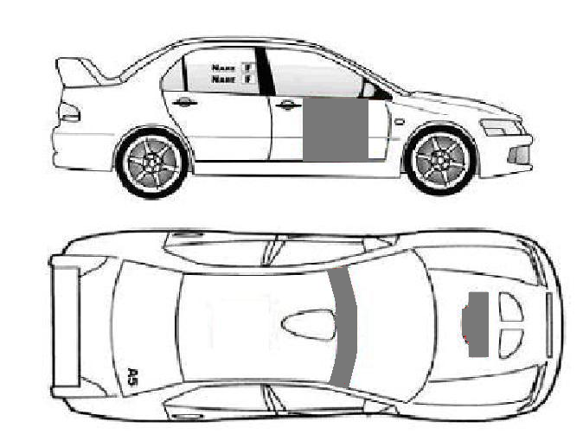

Grey areas are reserved for Idaho Rally Event Promotion and Competitor numbers.

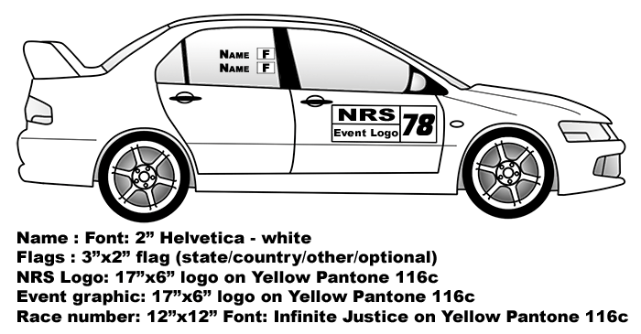

APPENDIX 3 SCRUTINEERING PROCESS

Scrutineering can take place at any time as outlined in the event schedule. Driver and co-driver need not be present, provided their safety equipment is all made available for inspection. Idaho Rally reserves the right to refuse entry to vehicles that are deemed unsafe or unsuitable.

**Chief Scrutineer,**  Carl Somerton

## APPENDIX 4 GENERAL CONDITIONS

A4.1 NEW DRIVER’S SEMINAR

See article 19

A4.2 GENERAL DRIVERS MEETING

All drivers are required to attend a general drivers briefing at the time and place noted in Article 3 of these regulations.

A4.3 START ORDER

The start order for Saturday, June 13 and Sunday, June 14 will be posted at the Official Notice Board at the Northwest Inn.

A4.4 OFFICIAL NOTICE BOARD

The Official Notice Board will be located in the registration room at Northwest Inn. During the rally you will find the board at the scoring booth in the service area.

A4.5 WEATHER CONDITIONS

The average temperature for June is 54-80 degrees (F).

A4.6 SUNRISE AND SUNSET

Saturday, June 13 2015 Mountain Daylight Time

Sunrise 06:03

Sunset 21:27

Sunday, June 14 2015 Mountain Daylight Time

Sunrise 06:03

Sunset 21:28

A4.6 STAGE CLOSING TIMES AND MPL

Maximum Permitted Lateness (MPL) is 30 minutes.

If in the opinion of the event Marshalls any competitor has no chance of arriving at a time control within their MPL that official may pull the competitors time card and open the stage to normal traffic.

A4.7 RUNNING OF THE RALLY  
 The transits are generous, so there is no need to speed if you get delayed.

## APPENDIX 5 MAPS AND GENERAL INFORMATION

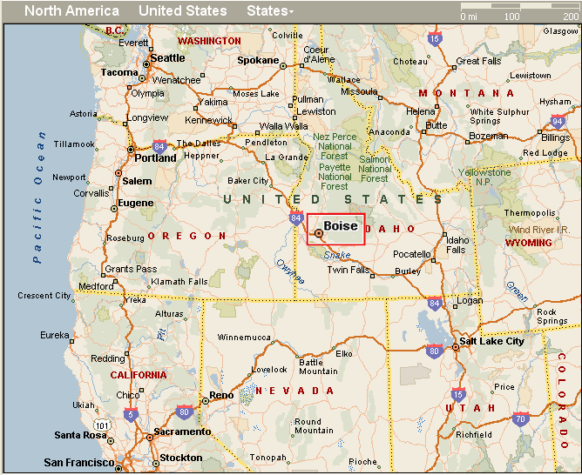A5.1 LOCATION OF THE RALLY

A5.2 Host Hotel and Main Service Park

Best Western + Northwest Lodge

6989 Federal Way

Boise, ID 83716

1-866-385-6343

1-208-287-2300

ALL RESERVATIONS NEED TO BE IN BY May 30, 2015

to get the special rate

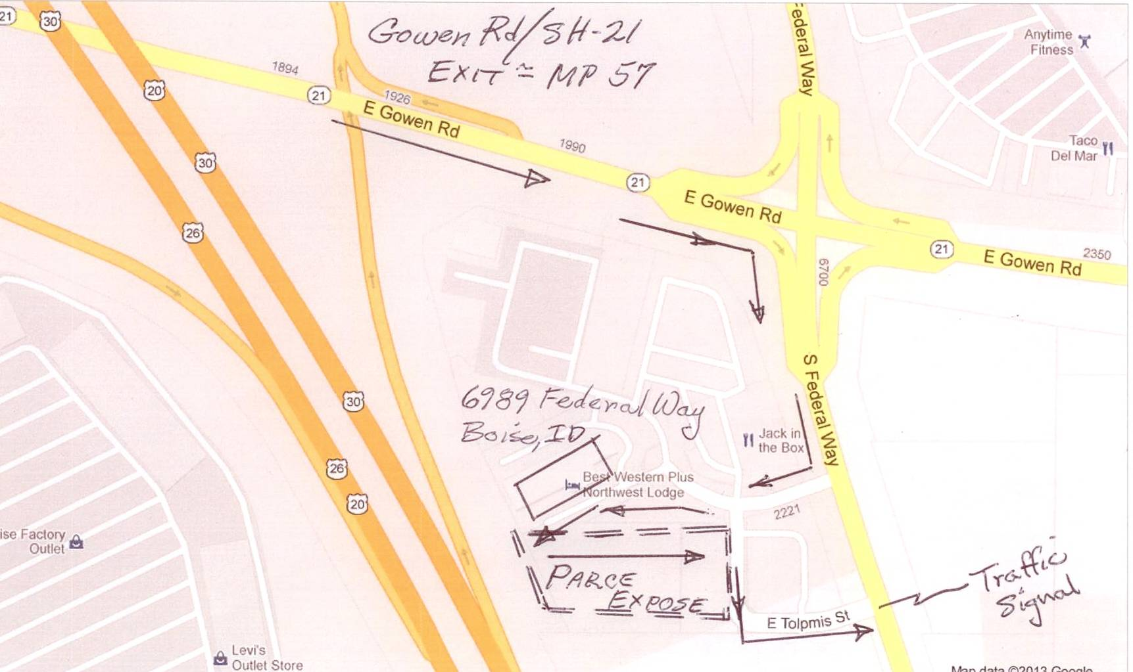

**NOTE: PARK EXPOSE ON MAP IS ACTUALLY THE MAIN SERVICE PARK**

A5.3 MAP OF STAGES

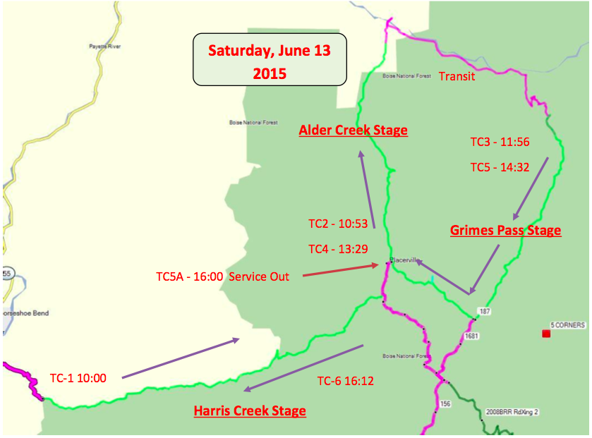

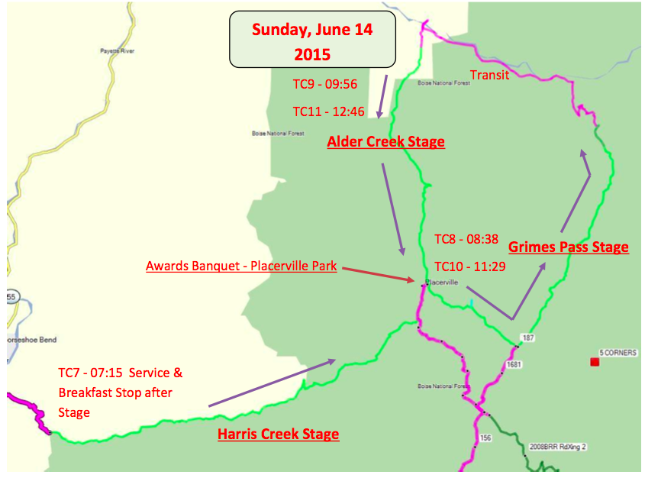

5.4 MAP TO START OF STAGES

**Directions in the Route Book**

**A5.5 MAP TO PARC EXPOSE FROM HOST HOTEL**

**Parc Expose Location: Larry Miller Subaru**

9380 West Fairview Avenue, Boise, ID 83704 - (208) 947-6300

|  |  |
| --- | --- |
| S Federal Way, Boise, Ada County, ID 83716-9604  43.537945, -116.154510 |  |
| 1. Start out going north on S Federal Way toward E Tolpmis St.MapHide Map | 0.2mi  *0.2 mi total* |
| 2. Turn left onto ID-21 / E Gowen Rd.MapHide Map   * ID-21 is 0.1 miles past E Hospitality Ln * If you reach E Lake Forest Dr. you've gone about 0.1 miles too far | 0.1 mi *0.4 mi total* |
| 3. Merge onto I-84 W / US-30 W toward Boise.MapHide Map | 7.2 mi  7 minutes  *7.5 mi total* |
| 4. Take the I-184 exit, EXIT 49, toward Franklin Rd / City Center.MapHide Map | 0.6 mi  *8.1 mi total* |
| 5. Take the Franklin Road exit.MapHide Map | 0.7 mi  1 minute  *8.8 mi total* |
| 6. Turn left onto W Franklin Rd.MapHide Map | 0.9 mi  1 minute *9.7 mi total* |
| 7. Turn right onto N Maple Grove Rd.MapHide Map   * N Maple Grove Rd is 0.2 miles past S Bird St * Michaels is on the corner * If you reach S Old Quarry Way you've gone about 0.1 miles too far | 1.0 mi  2 minutes *10.7 mi total* |
| 8. Turn left onto W Fairview Ave.MapHide Map   * W Fairview Ave is 0.2 miles past W Irving St * If you reach W Garverdale Dr. you've gone a little too far | 0.2 mi *10.9 mi total* |
| 9. 9380 W FAIRVIEW AVE is on the right.MapHide Map   * If you reach N Kimball St you've gone a little too far |  |
| 9380 W Fairview Ave, Boise, Ada County, ID 83704-8224  43.619469, -116.298569 |  |

Total Travel Estimate: **10.92 miles about 14 minutes**

A5.6 PLACERVILLE SERVICE and Camping in Placerville

Service Parking Instructions 2015;

Due to the number of competitors and service rigs, it has become necessary to implement some service parking requirements. We hope these will alleviate some of the difficulties that were encountered last year.

Parking is on a 1st come, 1st served basis. You can reserve a parking spot with your paid early entry registration. If your entry fee is not paid by the end of the early registration period the parking space will be reassigned.

The parking area designated as “Service Parking #1” is reserved for those who have used the area in the past with permission from the land owner. If a vacancy occurs, permission from the land owner, by special request through the Service Parking Coordinator, will be needed before parking is allowed.

A number of the parking areas are sized to single car teams. So if you are bringing 2 service trailers and 4 race cars the area behind the Museum probably would not work well for you. If you plan on bringing a larger service crew please contact the Service Parking Coordinator for recommendations.

Noncompliance with these directions could result in penalties and or fines.

Be safe and have fun. Remember, “Roads like these are why we Rally”

Thank You for your participation in the 2015 Idaho Rally.

George Thomas, 208-392-4230

geoandgeone@gmail.com

Service Parking Coordinator

Idaho Rally 2015

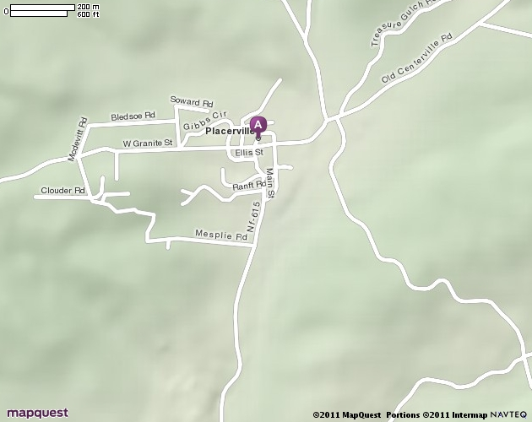

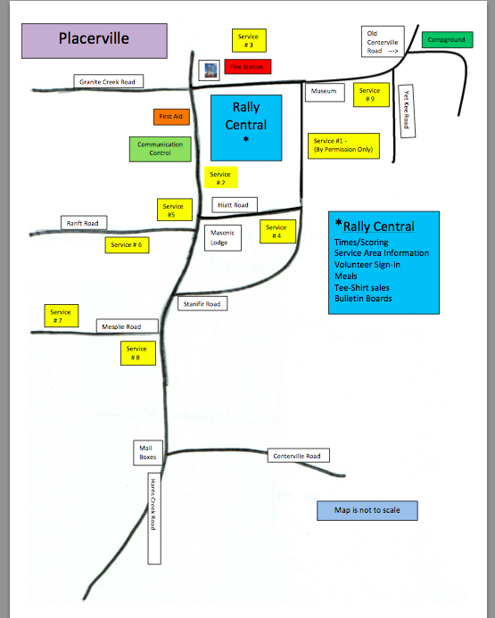

**You may also follow the Route book through Horseshoe Bend and Harris Creek Stage. It is shorter BUT more winding and steeper so campers should be aware that the Idaho City Route below is easier but longer.**

**Through Idaho City Route**

|  |  |
| --- | --- |
| 6989 S Federal Way, Boise, Ada County, ID 83716-9604  43.537945, -116.154510 |  |
| 1. Start out going north on S Federal Way toward E Tolpmis St.MapHide Map | 0.2 mi  *0.2 mi total* |
| 2. Take the 1st right onto E Gowen Rd / ID-21. Continue to follow ID-21 E.MapHide Map   * ID-21 E is just past E Hospitality Ln * Perkins is on the left * If you are on S Federal Way and reach ID-21 you've gone a little too far | 33.9 mi  46 minutes *34.1 mi total* |
| 3. Turn left onto Montgomery St.MapHide Map   * Montgomery St is just past Cottonwood St * Boise Basin Library is on the left * If you reach Main St you've gone a little too far | 0.4 mi  1 minute *34.4 mi total* |
| 4. Turn left onto Centerville Rd (Portions unpaved).MapHide Map   * Idaho City High School is on the corner | 5.7 mi  16 minutes*40.1 mi total* |
| 5. Turn left to stay on Centerville Rd (Portions unpaved).MapHide Map   * If you are on NF-307C2 and reach NF-379G6 you've gone about 1.9 miles too far | 6.0 mi  15 minutes  *46.1 mi total* |
| 6. Turn right onto Harris Creek Rd (Portions unpaved).MapHide Map | 0.02 mi  *46.1 mi total* |
| 7. Harris Creek Rd becomes Placerville Rd (Portions unpaved).MapHide Map | 1.1 mi  2 minutes  *47.2 mi total* |
| 8. Placerville Rd becomes S Main St (Portions unpaved).MapHide Map | 0.08 mi  *47.3 mi total* |
| 9. Welcome to PLACERVILLE, ID.MapHide Map   * Your destination is just past Hyatt St * If you reach Ellis St you've gone a little too far |  |

Total Travel Estimate: **47.29 miles - about 1 hour 23 minutes**

**Sunday morning route using Grimes Creek Road (Service personnel who are late can get through this way after stage is closed)**

|  |  |
| --- | --- |
| 6989 S Federal Way, Boise, Ada County, ID 83716-9604  43.537945, -116.154510 |  |
| 1. Start out going north on S Federal Way toward E Tolpmis St.MapHide Map | 0.2 mi  *0.2 mi total* |
| 2. Take the 1st right onto E Gowen Rd. ID-21. Continue to follow ID-21 E.MapHide Map   * ID-21 E is just past E Hospitality Ln * Perkins is on the left * If you are on S Federal Way and reach ID-21 you've gone a little too far | 23.9 mi  31 minutes  *24.1 mi total* |
| 3. Turn left onto Grimes Creek Rd (Portions unpaved).MapHide Map   * Grimes Creek Rd is 0.6 miles past Piske Ln. * If you reach Minneha Crk. Rd. you've gone about 0.8 miles too far | 14.2 mi  33 minutes  *38.3 mi total* |
| 4. Turn left onto Centerville Rd (Portions unpaved).MapHide Map | 4.6 mi  11 minutes  *42.9 mi total* |
| 5. Turn right onto Harris Creek Rd (Portions unpaved).MapHide Map | 0.02 mi  *42.9 mi total* |
| 6. Harris Creek Rd becomes Placerville Rd (Portions unpaved).MapHide Map | 1.1 mi  2 minutes  *44.0 mi total* |
| 7. Placerville Rd becomes S Main St (Portions unpaved).MapHide Map | 0.08 mi  *44.1 mi total* |
| 8. Welcome to PLACERVILLE, ID.MapHide Map   * Your destination is just past Hyatt St * If you reach Ellis St you've gone a little too far |  |

**5.6.1 Radio Frequencies for Rally**

|  |  |  |  |
| --- | --- | --- | --- |
| **Repeater Assignments and Freq. use** | | |  |
|  |  |  |  |
|  |  |  |  |
|  |  | Freq. w/ offset | PL |
|  |  |  |  |
|  | |  |  |
|  |  |  |  |
| Alder Cr |  | 444.075 + | 100 |
|  |  |  |  |
| Old Centerville/ Grimes Pass | | 443.975 + | 100 |
|  |  |  |  |
| Harris Cr. |  | 145.290 - | 100 |
|  |  |  |  |
| Simplex |  | 146.54 |  |
|  |  |  |  |
| FRS |  | Ch.5 |  |
| Grime Pass road guards |  | 464.55 |  |
| Scoring |  | 446.600 - | 100 |

## 5.7.1 TIME CARDS

MPL: Maximum Permitted Lateness is 30 minutes total. For road opening purposes on stage, any competitor whose time exceeds the Bogey time +15 minutes will have their time card pulled by sweep and be prohibited from finishing that stage. This will not prevent them from using Superrally rules and re-entering the Rally at a later point (either after a service or at the start of the next day). See NRS GRRs Article 2.22.6 for Superrally rules.

